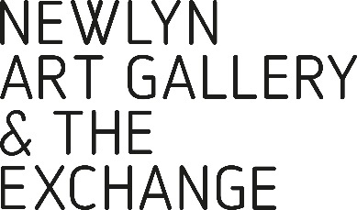
THE PICTURE ROOM
APPLICATION FORM FOR 2025

Please complete and return with a maximum of FIVE images of your work (jpg, or png format) along with the Equal Opportunities monitoring form to makers@newlynartgallery.co.uk by 09:00, Mon 30 Sep.

YOUR NAME
POSTAL
ADDRESS
EMAIL
YOUR WEBSITE
SOCIAL MEDIA LINKS

Please briefly outline your exhibition history, or attach a CV

Artist Statement (400 words max):

Details of images of works sent
IMAGE #1
TITLE
MEDIUM
DIMENSIONS
RRP

IMAGE #2
TITLE
MEDIUM
DIMENSIONS
RRP

IMAGE #3
TITLE
MEDIUM
DIMENSIONS
RRP

IMAGE #4
TITLE
MEDIUM
DIMENSIONS
RRP

IMAGE #5
TITLE
MEDIUM
DIMENSIONS
RRP

With an emphasis on affordable works The Picture Room at Newlyn Art Gallery offers the opportunity to buy paintings, prints and drawings by some of the region’s most recognised artists. All profits from sales directly help to support the gallery’s education and exhibition activities.

