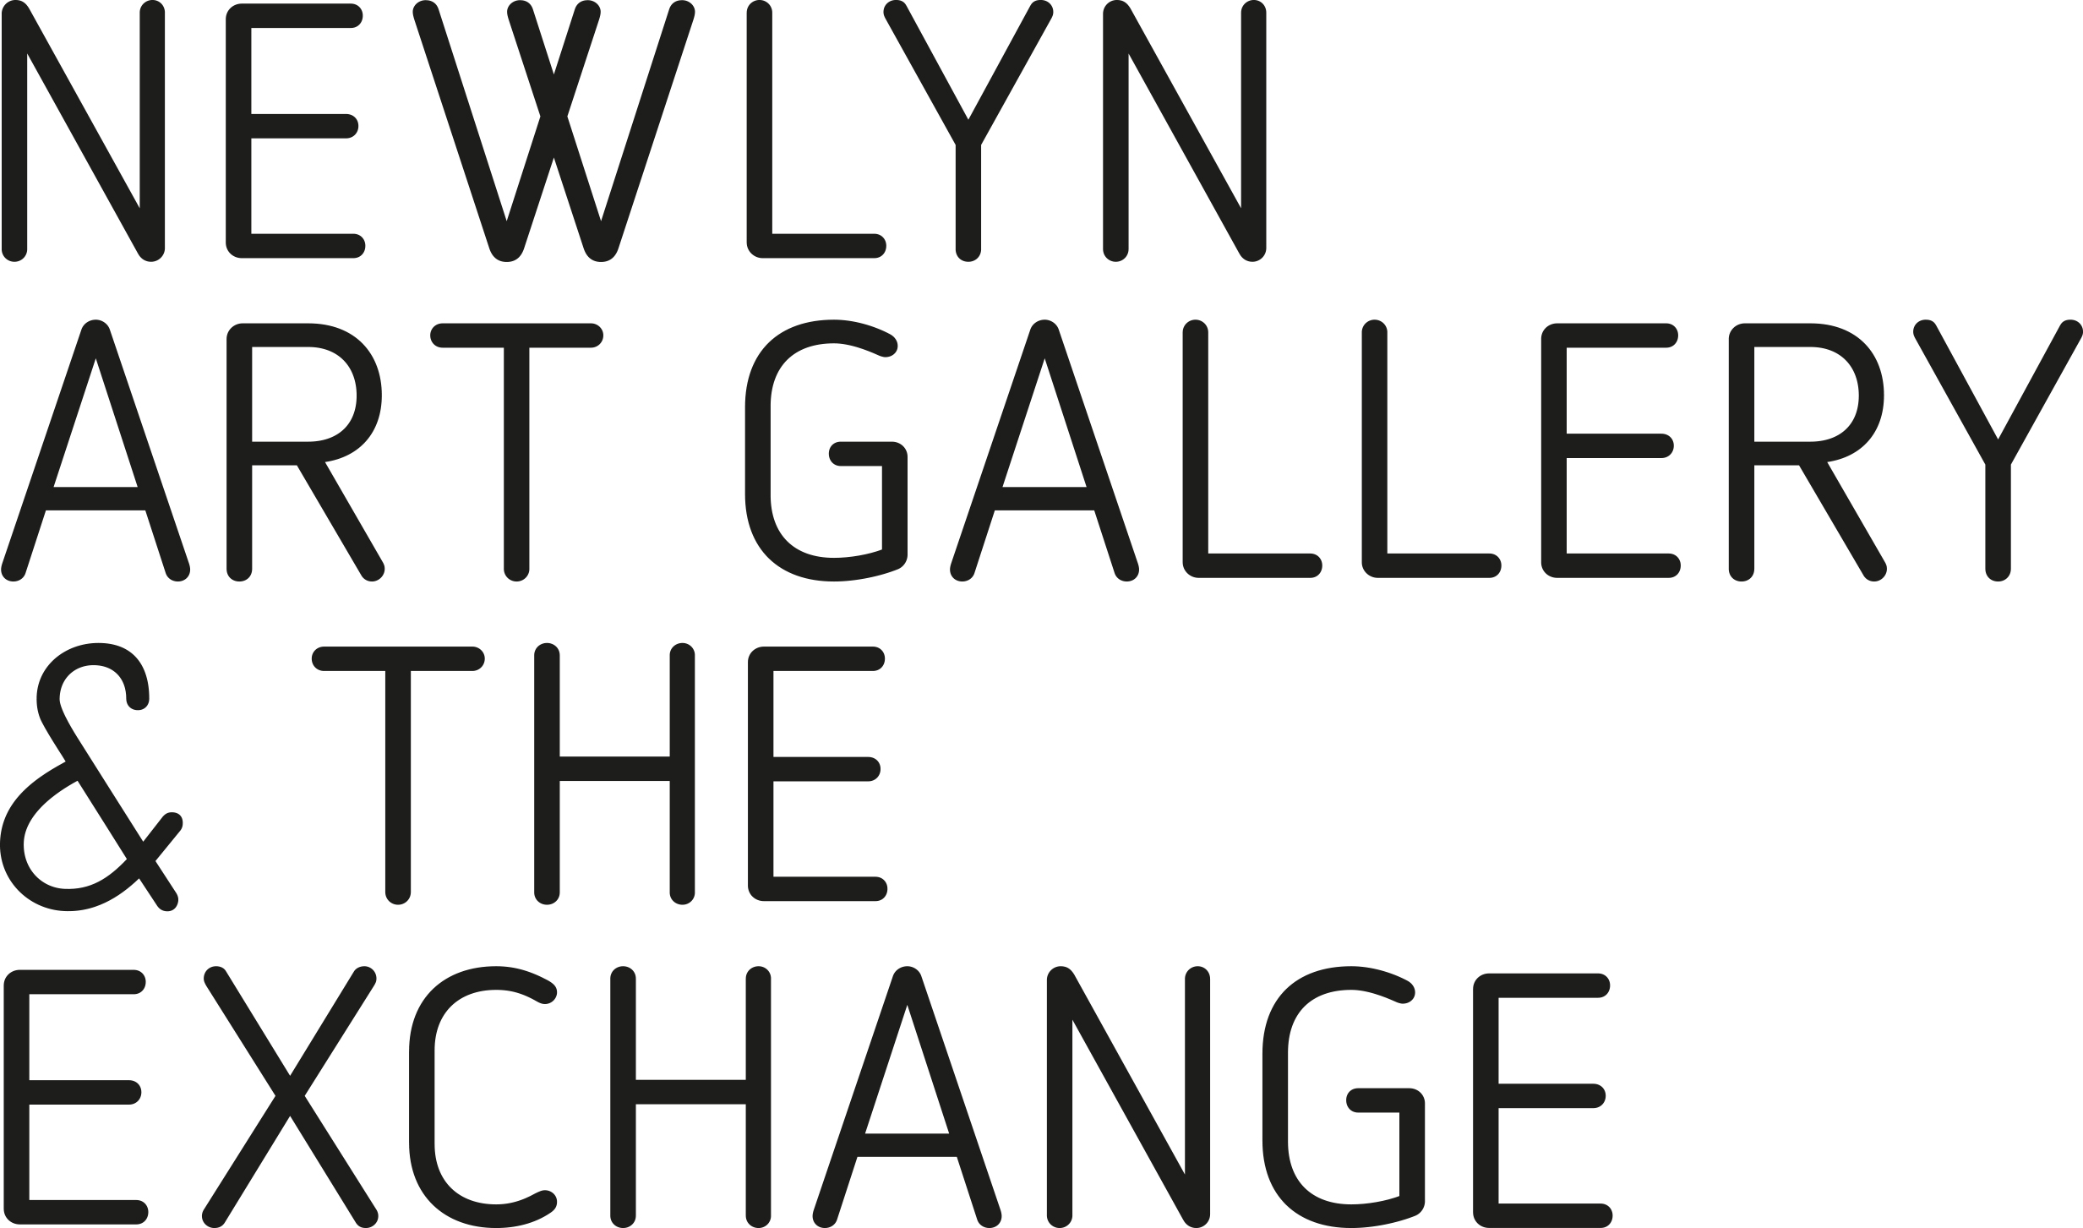
HIRE AGREEMENT

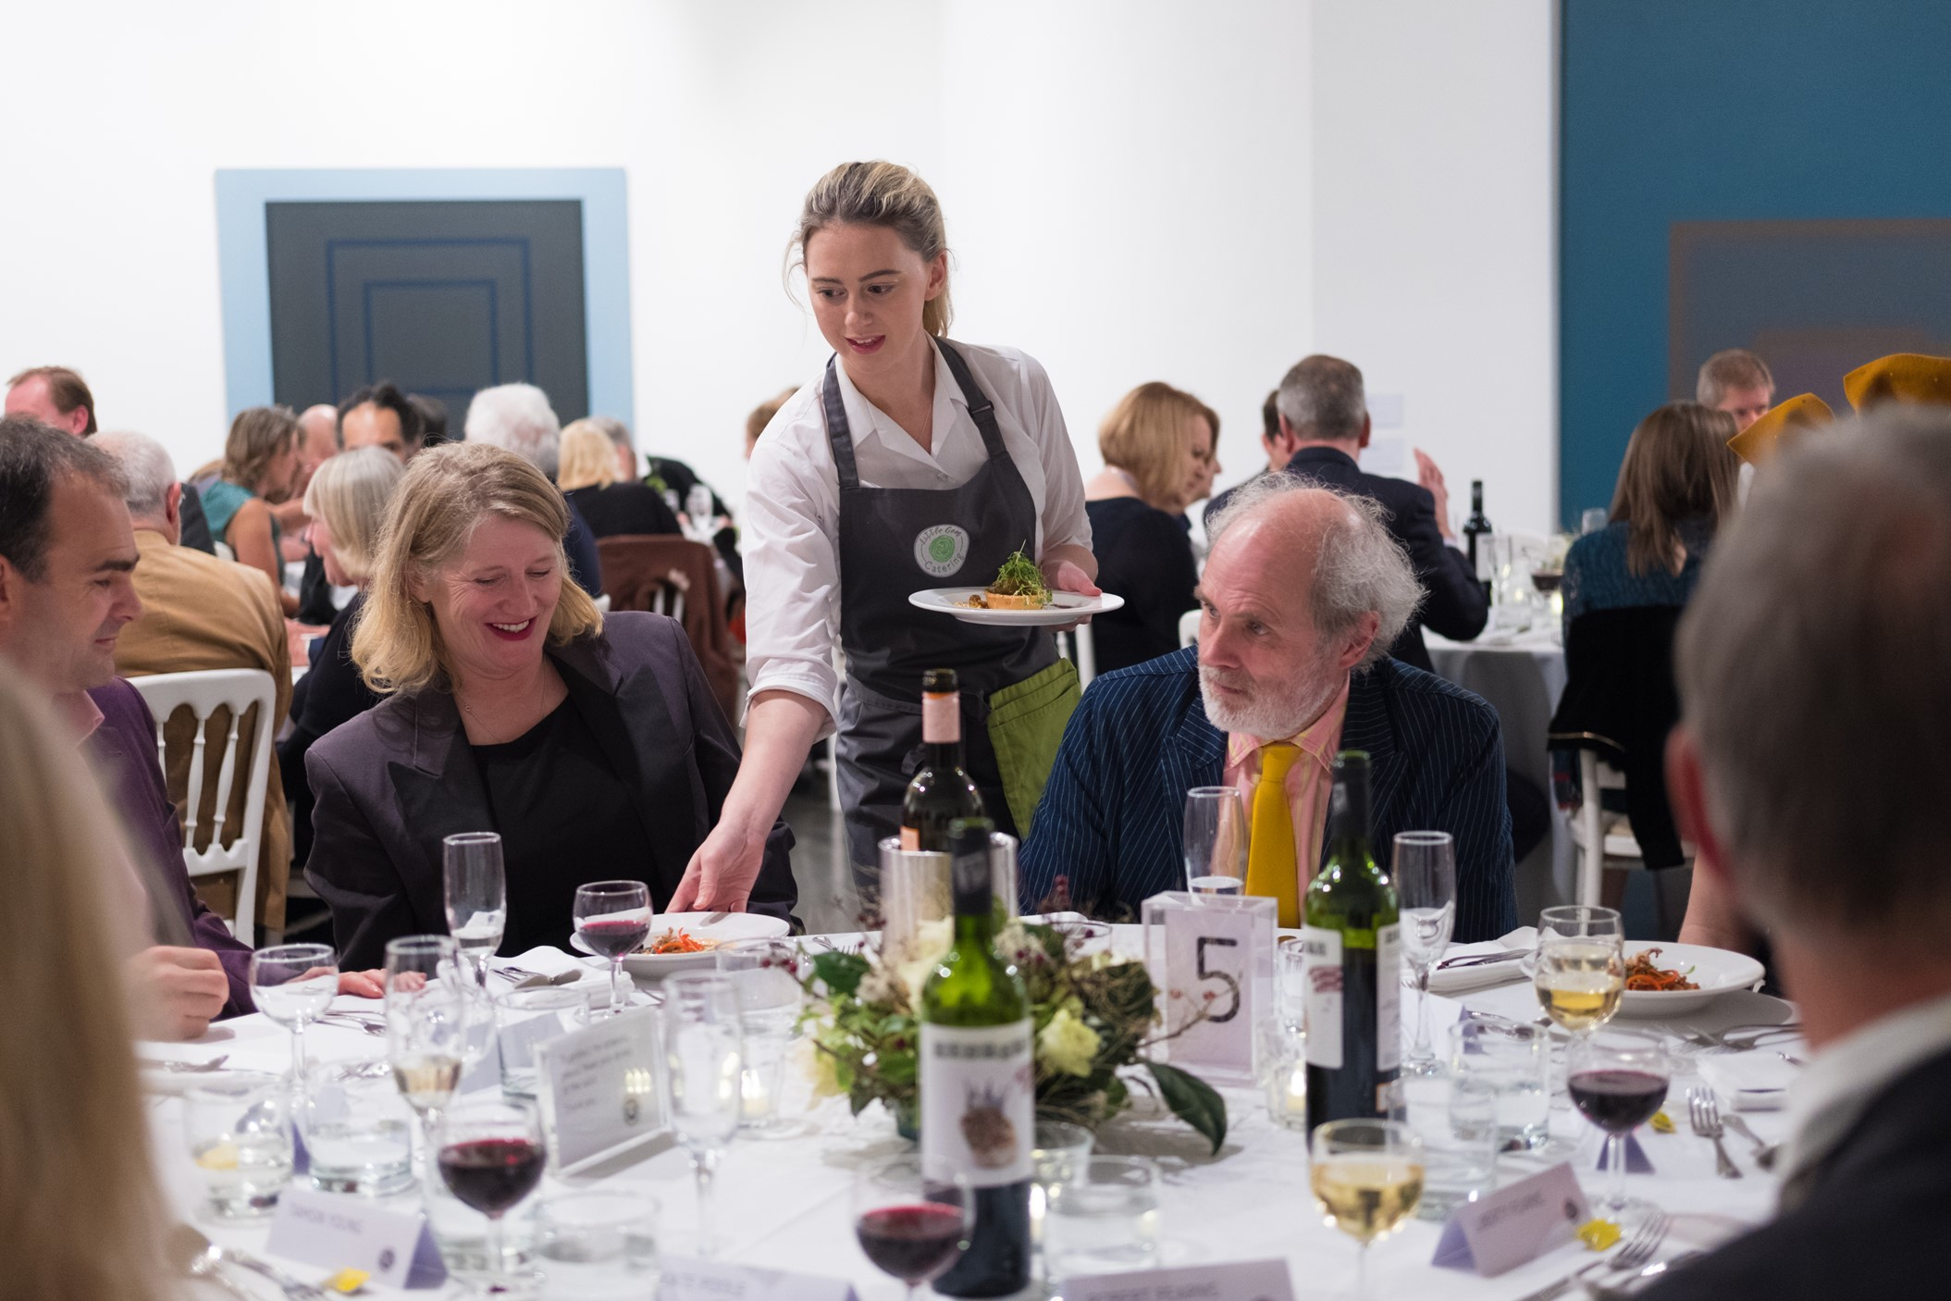

Gala Dinner for 100 people in the main gallery at The Exchange
Photo Credit: Lee Searle

Thank you for your interest in venue hire at Newlyn Art Gallery & The Exchange.
Please read the following hire agreement and policy details and fill in the event forms with any details you can. We collect these details so we can make sure your event goes as smoothly as possible.

EVENT NAME:

AGREEMENT OF HIRE NEWLYN ART GALLERY LTD

This form confirms the details of the hire. Please complete the form and make any amendments you feel are needed and return to Tegen.Tossell@newlynartgallery.co.uk

Event Name & Date:

1.Name and Address: | Phone/Email:
2. Organisation: | 2.1. Please quote your charity registration number if applicable:
3. Space required: | 3.1. Additional Facilities required (tables/chairs/catering/ /AV equipment):
4.Date(s) and times required:  Please include the time you need for setting up and clearing away. | 4.1. Is it intended to sell alcohol?
5. Hire purpose/event type: | 5.1. Will you have a guestlist:
 | 5.2. Number of people attending:
 | 5.3. Will a charge be made for admission:
6. Fee:

I have read the conditions of hire and agree that the above details are all correct.
Date: | Signed:
Event Details & running order | For use by Newlyn Art Gallery Staff
Newlyn Art Gallery contact:
The Exchange contact:
Telephone:
Email:
Number of guests:
Ticket price and where to order:
Guest speakers or entertainment:
Catering arrangements:
Staff:
Event Duty Manager
Catering staff
Volunteer/ front desk
Running order / Schedule | Please let us know the timings of your event.
Equipment needed:

After the event:
Pack down staff

HIRE POLICY & AGREEMENT

Premises may only be used for the purpose for which they have been hired.

The core business of Newlyn Art Gallery Ltd is to provide a programme of contemporary art to the region. If at any point a hire disrupts this core business or violates any of the terms & conditions set out in the hire agreement, the gallery reserves the right to discontinue the hire. In this situation no refund will be made.

If a problem is created for the running of the gallery, by the hire, Newlyn Art Gallery Ltd reserves the right to change the area of hire to another location within the two gallery venues. The new location will be appropriate for the purpose of the hire.

The hirer must be over 18 years of age.

Failure to comply with the conditions of the Hire Agreement may incur additional charges.

Individuals or groups hiring gallery premises are required to observe the conditions covering community use of the gallery premises attached to this document. These rules are there to protect you and Newlyn Art Gallery Ltd

Any hire requires a minimum of one member of staff to be present. In most cases this member of staff will be the Duty Manager of the hire and is included in the hire fee. The hire fee does not include additional staffing, catering or any A/V equipment unless specified otherwise in the hire agreement. Additional staff will be charged at £15/h plus VAT. Additional staffing needs will be specified prior to the hire by Newlyn Art Gallery Ltd.

To book your event, please return the completed and signed Booking Form & Agreement of Hire together with a payment for the deposit.

The deposit is 50% of the total hire fee, for bookings made more than 30 days prior to the date of the hire. The full balance is due 30 days prior to the hire. The deposit is 100% of the hire fee if the booking is made less than 30 days prior to the date of the hire.

Payments can be made in cash, by card or by BACS

CANCELLATION

The deposit is non-refundable should the hirer decide to cancel the event.

The hirer must give a minimum of 7-day notice of cancellation to Newlyn Art Gallery Ltd.

Failure to pay the total hire fee prior to the event will result in the cancellation of the event, with the deposit being retained.

Newlyn Art Gallery Ltd reserves the right to cancel any hire without notice in the event of unforeseen circumstances and shall not be held liable or required to pay any compensation for any loss sustained as a result. However, we will endeavour to give the hirer the maximum notice possible. Newlyn Art Gallery Ltd will refund 100% of the hire fee.

The core business of Newlyn Art Gallery Ltd is to provide a programme of contemporary art to the region. If at any point a hire disrupts this core business or violates any of the terms & conditions set out in the hire agreement, the gallery reserves the right to discontinue the hire. In this situation no refund will be made.

INSURANCE

The hirer is liable for all damages to the premises arising from the hiring, however and by whoever caused, and shall indemnify the Management against all loss, damage and expense. Any damage caused shall be reported to the Duty Manager immediately.

All hirers must ensure that they have adequate Public Liability Insurance and where appropriate Employers’ Liability Insurance. Newlyn Art Gallery Ltd may require proof of this insurance prior to the hire.

USE OF PREMISES

The purpose of hire must be submitted to and approved by the Director or Deputy Director in advance of booking confirmation.

No smoking will take place inside the premises.

The hirer shall at the end of the hire period leave the premises in a clean and orderly state. Failure to do so may result in a charge for cleaning at commercial rates.

The hire of gallery premises does not include the use of any gallery equipment within the premises unless specified, nor use of the gallery car park.

The Director reserves the right to refuse a particular activity if it is felt it is not appropriate use of the facility or is not compatible with the gallery’s equal opportunity policy.

HEALTH & SAFETY

All health and safety regulations are in place and must be complied with. The hirer is responsible for the Health and Safety of all persons using the hired premises.

Newlyn Art Gallery Ltd will produce a risk assessment together with the hirer prior to the event. The hirer will be given a copy of this risk assessment and must comply by all conditions & requirements therein.

Newlyn Art Gallery Ltd will provide staffing and will decide if additional security is needed and at what charge it can be provided.

The hirer must, prior to the hire, be fully aware of the fire precautions and evacuation procedures. The Operations Manager will provide all necessary information.

If the hirers are bringing their own electrical equipment to use on the gallery premises, the equipment must be PAT tested. The Operations Manager can advise you on this should you have any queries – 01736 363715.

LICENSING

Where a license is required for any purpose proposed by the hirer for use of the premises, this shall be notified to the Operations Manager and a copy of the license supplied to the Operations Manager prior to the hire.

The hirer shall strictly observe the conditions of any license agreement granted in respect of the hired premises.

For lettings involving a play, music, dancing or film show, a public license may be required. The hirer must check with the gallery and/or the licensing authority.

The sale of alcohol on gallery premises is permitted only if it is approved by the Director and, where appropriate, subject to obtaining a license to sell alcohol.

CATERING & TECHNICAL EQUIPMENT

The gallery can provide limited catering. Should the hirer prefer not to buy refreshments through the gallery, corkage charges of £5 per bottle for wine will apply. All catering charges to be determined by the Operations Manager.

Any external caterers are to liaise with the Operations Manager. External caterers need to leave the premises as they found them. The kitchen is not for hire, but use of kitchen and kitchen utensils can be agreed with the Operations Manager and at their discretion only.

Technical equipment may be available. Additional charges for technical equipment may apply and will be determined by Newlyn Art Gallery Ltd.

HEALTH & SAFETY

This notice is an abridged version of the full Health and Safety Regulations in force at Newlyn Art Gallery Ltd.

In the event of a FIRE, the Fire Alarm sounds continuously and you are required to leave all your belongings behind and make your way out of the building, following the Fire Exit signs as quickly as possible. Staff will help ensure that everyone leaves in a calm manner and are led to Muster point.

MUSTER POINTS:
The Exchange – in front of New Street Gallery on New Street
Newlyn Art Gallery – on Newlyn Green behind the gallery building

DO NOT USE THE LIFTS. Visitors who have a disability will be assisted in their evacuation as appropriate by the responsible person present.

The gallery operates a strict NO SMOKING policy. Visitors are required to abide by this regulation. Smoking is permitted outside the building only, in the car park area at The Exchange and in the garden at Newlyn.

If you are in need of any emergency assistance whilst in the gallery, the gallery staff can be contacted from the Front of House phones on the following numbers:

Main Gallery: 01736 363715

