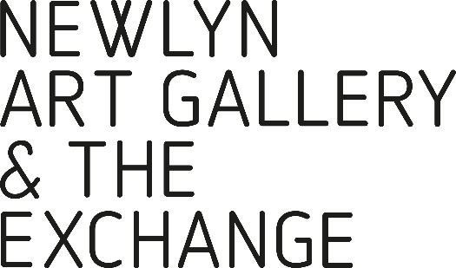
VOLUNTEER
REGISTRATION FORM

YOUR NAME

ADDRESS

E-MAIL

PHONE
.
DOB

Consent for Volunteers Under 18

Name of Parent/ Guardian:

Signed parent /Guardian

PLEASE PROVIDE TWO CONTACTS AS REFEREES AND STATE THE CAPACITY IN WHICH THEY KNOW YOU:
1. | 2.

Due to the nature of the role, Newlyn Art Gallery Ltd may require you to be subject to references and in some cases to a Criminal Records Bureau Enhanced Disclosure.

Have you have already been DBS checked?
YES NO Date of Check: .........................

THIS INFORMATION WILL BE KEPT FOR THE PURPOSES OF THE GALLERY VOLUNTEERS RECRUITMENT ONLY AND WILL NEVER BE DISCLOSED TO A THIRD PARTY.

EMERGENCY CONTACT DETAILS

Emergency Contact
Name
Address

Postcode

Phone  Please indicate if you have a preference how we contact you. | Daytime | Evening

Emergency Contact
Name
Address

Postcode

Phone  Please indicate if you have a preference how we contact you. | Daytime | Evening

Please let us know if you have any specific requirements to enable you to volunteer. This may be with access, hearing, extra support or anything else.

Image
please insert or draw a picture of yourself

Signed ………………………………………………….… Name ………..…………….………………………………
Date …………………………………………………..……

