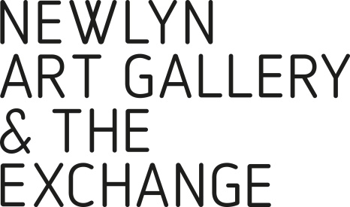

JOB APPLICATION FORM
If you require this application form in any other format,
please email info@newlynartgallery.co.uk or call 01736 363715

Position applied for: | Finance Officer

PERSONAL DETAILS:
Title |  | Forename(s) |  |  | Surname
Address:
NI Number
Landline |  |  |  | Mobile Number
Email

Are there any restrictions on you taking up employment in the UK? | Y / N
If yes, please provide details below

EDUCATION: (please complete in full and use a separate sheet if necessary)
Schools/Colleges/University | Qualifications Gained

EMPLOYMENT HISTORY: (please complete in full and use a separate sheet if necessary)
From | To | Name of Employer
Job Title

Duties
Reason for leaving

From | To | Name of Employer
Job Title

Duties
Reason for leaving

From | To | Name of Employer
Job Title

Duties
Reason for leaving

REFERENCES (please note here the names and contact details of two people we may contact for
both character and work experience references)
Reference 1 Name and Contact Details | Reference 2 Name and Contact Details
Known in the capacity of: (i.e. Manager/Education) | Known in the capacity of: (i.e. Manager/Education)
May we contact them prior to interview? | May we contact them prior to interview?
Y/N | Y/N

LEISURE:
Please note here your leisure interests, sports and hobbies, other pastimes etc.
GENERAL COMMENTS
Please detail here your reasons for this application, your main achievements to date and the strengths you would bring to this post.

Specifically, please tell us how your knowledge, skills and experiences meet the requirements of this role as summarised in the job description. You may have transferable experience from other areas of work which make you suitable for this role which we’d very much like to know about.

(Please continue on a separate sheet if necessary)

CRIMINAL RECORD:
Please note any criminal convictions except those 'spent' under the Rehabilitation of Offenders Act 1974. If none please state. In certain circumstances employment is dependent upon obtaining a satisfactory Disclosure & Barring Certificate from the Disclosure & Barring Service/Disclosure Scotland.

DISABILITY CONFIDENT EMPLOYER:

As a Disability Confident employer, we will ensure that a fair and proportionate number of disabled applicants that meet the minimum criteria for this position will be offered an interview. Therefore, please indicate below whether you consider yourself to be disabled under the Equality Act 2010. Please mark ‘X’ in the appropriate box.
Yes |  | No
Prefer not to say |  | Don’t know

DECLARATION (Please read this carefully before signing this application)
- I confirm that the above information is complete and correct and that any untrue or misleading information will give my employer the right to terminate any employment contract offered.

- Should we require further information and wish to contact your doctor with a view to obtaining a medical report, the law requires us to inform you of our intention and obtain your permission prior to contacting your doctor. I agree that the organisation reserves the right to require me to undergo a medical examination. In addition, I agree that this information will be retained in my personnel file during employment and for up to six years thereafter and understand that information will be processed in accordance with the Data Protection Act.

- I agree that should I be successful in this application, I will, if required, apply to the Disclosure & Barring Service/Disclosure Scotland for a Disclosure & Barring Certificate. I understand that should I fail to do so, or should the disclosure not be to the satisfaction of the company any offer of employment may be withdrawn or my employment terminated.

Signed | Date

Thank you for your application. Please send your completed form to opportunities@newlynartgallery.co.uk

