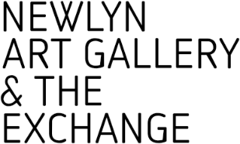

APPLICATION FORM TO SUPPLY WORK FOR SALE
IN NEWLYN ART GALLERY & THE EXCHANGE SHOPS

At Newlyn Art Gallery & The Exchange we want to support small, independent makers, based in Cornwall, the UK, and abroad by stocking their work in our two gallery-based shops, one at The Exchange in the centre of Penzance, and one in Newlyn Art Gallery. We also have a busy online shop, selling to customers all over the country.
In our shops we want to offer our visitors and customers a range of quality, handmade and handcrafted work, including, ceramics, jewellery, textiles, woodwork, and homewares such as candles and soaps.
We are looking for a wide range of ceramics, from affordable, to high-end, one-off pieces. These could be functional homeware, or decorative art pieces. Jewellery should preferably be sustainable and complement our ceramic pieces, with muted tones, and of course be well crafted.
We are currently looking for new makers and if you would like to have your work in our shops, please complete the form below and return to us for consideration.
Newlyn Art Gallery & The Exchange applies a comission of 50% to any sale.
We look forward to hearing from you.

APPLICATION FORM

Your reason for applying.

Please send images of your work that you wish to sell in our gallery shops, or include links to here to the relevant items on your website.

Please tell us about your process when making your work.

Do you have a wholesale list for your works? If so, please list below.

On sale price range (including 50% commission)

We regularly feature work from our shop on our social media channels and with featured artist articles on our online shop. We take our own in-house photography for this purpose.
Please confirm that you agree to us promoting your work in this way and that you will share/repost our social media posts as appropriate.
(If you do not agree to this, please can you tell us why)

YOUR CONTACT DETAILS

Name:

Address:

Email:

Contact Number:

Please list below your social media accounts that you use to promote your work. Please include your @username so that we might follow you.

Thank you for your application. We look forward to seeing your work and will be in contact soon regarding your application.

