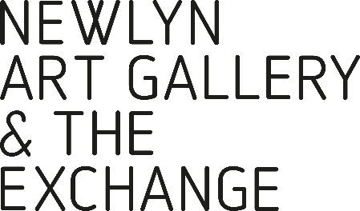
EQUAL OPPORTUNITIES
MONITORING FORM

CONFIDENTIAL
We are an equal opportunity organisation. The aim of our policy is to ensure that no artist, applicant or employee receives less favourable treatment because of age, disability, gender reassignment, marriage and civil partnership, pregnancy or maternity, race, religion or belief, sex or sexual orientation. And also to ensure our exhibiting artists represent the diversity of society.
To help us would you provide the following information:
AGE
What is your age? Please mark ‘X’ in one box only.
16-19 |  | 20-24 |  | 25-29 |  | 30-34
35-39 |  | 40-44 |  | 45-49 |  | 50-54
55-59 |  | 60-64 |  | 64+

DISABILITY
A disabled person is defined under the Equality Act 2010 as someone with a ‘physical or mental impairment which has a substantial and long-term adverse effect on that person’s ability to carry out normal day-to-day activities.’ Please indicate below whether you consider yourself to be disabled under the Equality Act 2010. Please mark ‘X’ in the appropriate box.
Yes |  | No
Prefer not to say |  | Don’t know

ETHNIC ORIGIN
We want to ensure that all applicants are treated equally whatever their race, colour or ethnic origin. To do this we need to know about the ethnic origin of people who apply to join us. These categories were used in the 2011 Census and are listed alphabetically. We have added Cornish as an option. Which group do you most identify with? Please mark ‘X’ in the appropriate box.
British/Mixed British |  |  |  | Asian
English |  |  |  | Bangladeshi
Irish |  |  |  | Indian
Scottish |  |  |  | Pakistani
Welsh
Any Other?  (please specify below) |  |  |  | Any other Asian background  (please specify below)
Black |  |  |  | Chinese
African |  |  | Any Chinese background (please specify below)
Caribbean
Any other Black background
(please specify below)
Mixed Ethnic Background |  |  | White
Asian and White |  |  | Any White background (please specify below)
Black African and White
Black Caribbean and White |  |  | Any other Ethnic Background (please specify below)
Any other Mixed ethnic background (please specify below)
 |  |  | Cornish

SEX
Please state your sex
Female |  | Male
transgender |  | gender neutral
agender |  | non-binary
genderqueer |  | other

SEXUAL ORIENTATION
We want to ensure that all applicants are treated equally whatever their sexual orientation. To do this we need to know about the sexual orientation of people who apply to join us. We should therefore be grateful if you would complete the following question. Your answer will be treated in the strictest confidence and will not affect your job application in any way.
Which group do you most identify with?
The options are listed alphabetical order. Please mark ‘X’ in one box only.
Bi-Sexual |  | Gay woman/lesbian |  | Gay man
Heterosexual/  straight |  | Other |  | Prefer not to say

RELIGION
What is your religion or belief (including non-belief)? Please mark ‘X’ in the box below as appropriate.
Agnostic |  | Atheist |  | Bah’ai |  | Buddhist
Christian Catholic |  | Christian Protestant |  | Christian Other |  | Hindu
Humanism |  | Jain |  | Jewish |  | Muslim
Pagan |  | Sikh |  | Rastafarian |  | Shinto
No religion or belief |  | Prefer not to say |  | Other |  | Please specify below, if you wish

ADVERTISING EFFECTIVENESS
We would like to monitor the effectiveness/impact of advertising vacancies and seeking to put the various forms of advertising to the best use to attract as diverse a range of candidates as possible. We would to know how you became aware of this vacancy. Please mark ‘X’ in the appropriate box(es) below:
Our Website |  | Other Website  (please specify)
Job Centre |  | Word of Mouth |  | Social Media
Other

Thank you for your interest in working at Newlyn Art Gallery & The Exchange.
Please return this form, along with your application form to opportunities@newlynartgallery.co.uk
Good luck, and we will be in touch.
