Group Visit
Booking Form
Please complete and return this form to groupbookings@newlynartgallery.co.uk

GROUP LEAD DETAILS
School / College Name:
Address:

Your Name:

Your Email Address:

Mobile Contact number:
[For use on day of visit]

DETAILS OF VISIT
Date:

Time and duration:

Which venue will you be visiting [please highlight]
Newlyn Art Gallery The Exchange

Year Group / age range of students:

Number of students in group: | Number of staff with group:
Focus of visit:

Any special requirements?

Covid – 19 safeguarding
- Please provide a copy of your risk assessment prior to arrival

- Please could the Group Lead complete our secure online form on the morning of your visit. This can be done onsite, by scanning the QR code below or going to www.newlynartgallery.co.uk/track-and-trace/

TRACK & TRACE
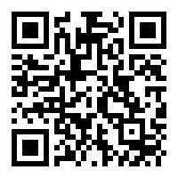

We are collecting your data to comply with government guidelines, it will only be used for track & trace and for no other purpose. Your data will be securely stored and then destroyed after 21 days if there is no need to use it.

Please complete this form and email to groupbookings@newlynartgallery.co.uk
We look forward to welcoming you and hope you enjoy your visit.

