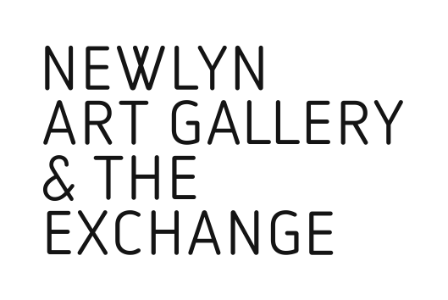

Fragment24a
Billboard
Submission Form

Many & Beautiful Things
29 Sep – 5 Jan 2019

Name:

Address:

Contact telephone number:

Contact email address:

Website link:

Brief description of work / artist statement:

Please submit up to 3 low res images of no more than 1MB each for this stage.

Work 1.
Title:

Image medium

Original size of file:

Work 2.
Title:

Image medium

Original size of file:

Work 3.
Title:

Image medium

Original size of file:

Please email your completed submission form, with images attached, by 20 Aug 2018 to blair.todd@newlynartgallery.co.uk

The billboard images will be selected and curated by Oliver Udy, photographer and editor of Antler Press, and Blair Todd, Programme Curator, Newlyn Art Gallery & The Exchange.

Please Note:

A high res copy will be required of all work selected.

A selection of billboard images may also be reproduced as postcards for publicity purposes and sale in the gallery shop. All artists will be credited appropriately

Selected artists will be contacted by Fri 31 Aug 2018.

The Exchange, Princes Street, Penzance , TR18 2NL
Newlynartgallery.co.uk 01736 363715

