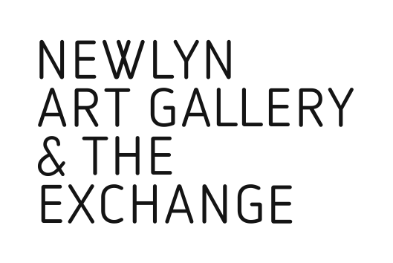

Fragment24a
Instagram Takeover
Submission Form

Name:

Address:

Contact telephone number:

Contact email address:

Instagram link:

Preferred Takeover Slot

Fri 5 – Sun 7 Oct
Fri 2 – Sun 4 Nov
Fri 30 Nov – Sat 2 Dec
Fri 28 – Sun 30 Dec

Brief artist statement / approach to Instagram Takeover:

The Instagram Takeover element of Fragment24a will be selected and guided by Kathy Hill, Marketing Manager and Cat Gibbard, Programme Curator at Newlyn Art Gallery & The Exchange.

Are you also submitting to:
The Collaborator’s Annual Exhibition?
Billboard?

The Exchange, Princes Street, Penzance , TR18 2NL
Newlynartgallery.co.uk 01736 363715

Please return to:
cat.gibbard@newlynartgallery.co.uk

