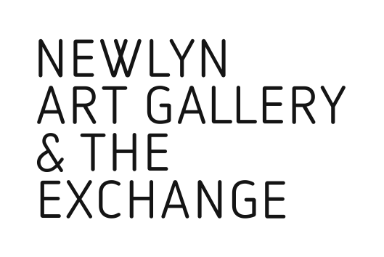

Fragment24a
The Collaborators’ Annual Exhibition
29 Sep – 5 Jan 2019
The Engine Room, The Exchange

SUBMISSION FORM

Name:

Address:

Contact telephone number:

Contact email address:

Website link:

You may submit up to 3 works in any media for consideration.

Work 1.
Title:

Medium:

Size or duration:

Work 2.
Title:

Medium:

Size or duration:

Work 3.
Title:

Medium:

Size or duration:

Brief description of work / artist statement:

Please email your completed submission form, attaching up to 3 images of no more that 1MB each, to cat.gibbard@newlynartgallery.co.uk

Fragment24a (a Many & Beautiful Things satellite exhibition) will be selected and curated by Producer Amos Jacob, and Cat Gibbard, Programme Curator at Newlyn Art Gallery & The Exchange.

Selected artists will be contacted by Fri 31 Aug 2018.

Please note: If selected, a loan form will be issued, to be completed and signed by both gallery and artist.

The Exchange, Princes Street, Penzance , TR18 2NL
Newlynartgallery.co.uk 01736 363715

