Private and confidential
Return this form to: James.green@newlynartgallery.co.uk by midnight on Monday 25th September

Position applied for Operations Officer, The Exchange (Maternity Cover)

Name: Title Forename(s) Surname

Address:

Postcode
N.I. number
Telephone number Landline Mobile

Are there any restrictions on you taking up employment in the UK?
Yes [ ] No [ ] (If Yes, please provide details)

Application for employment
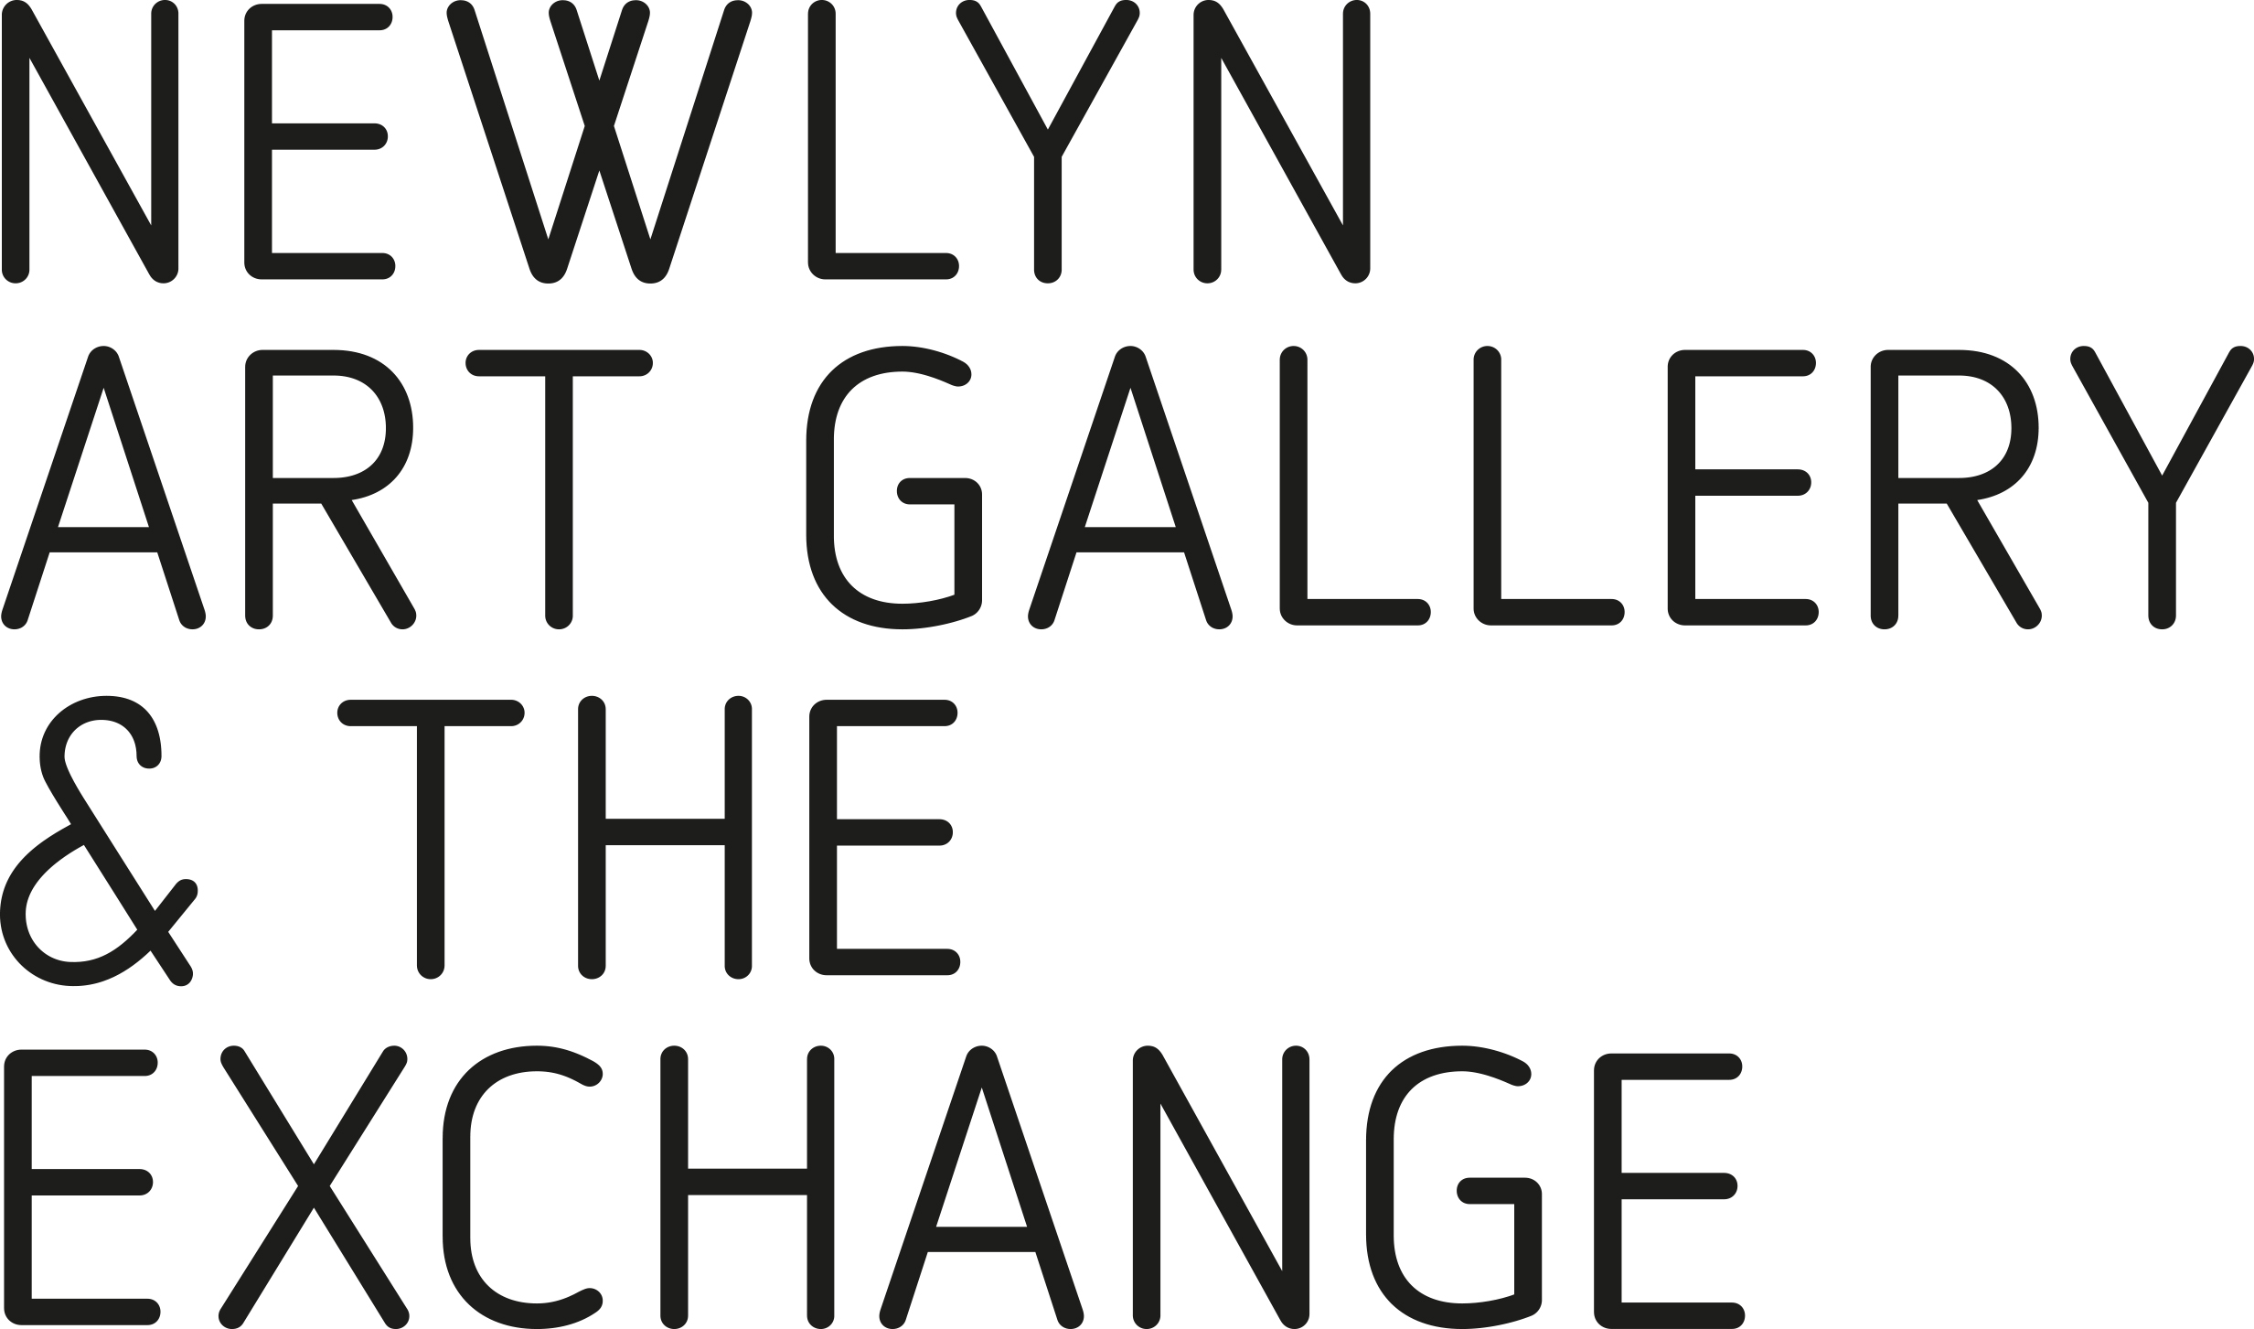

Education Schools/Colleges/University Qualifications Gained

Current driving licence?
Yes [ ] No [ ] Groups: Expiry date

Details of endorsements:

From To Name and address

Job title Rate of pay
Duties

Reason for leaving

From To Name and address

Job title Rate of pay
Duties

Reason for leaving

From To Name and address

Job title Rate of pay
Duties

Reason for leaving

Notice required

Employment history: (please complete in full and use a separate sheet if necessary)
From To Name and address

Job title Rate of pay
Duties

Reason for leaving

Criminal record Please note any criminal convictions except those 'spent' under the Rehabilitation of Offenders Act 1974. If none please state. In certain circumstances employment is dependent upon obtaining a satisfactory Disclosure & Barring Certificate from the Disclosure & Barring Service/Disclosure Scotland.

Other employment Please note any other employment that you would continue with if you were to be sucessful in obtaining this position.

References Please note here the names and addresses of two persons from whom we may obtain both character and work experience references.

1. 2.
Known in the capacity of: (i.e. Manager/Education) Known in the capacity of:

Declaration (Please read this carefully before signing this application)
- I confirm that the above information is complete and correct and that any untrue or misleading information will give my employer the right to terminate any employment contract offered.

- Should we require further information and wish to contact your doctor with a view to obtaining a medical report, the law requires us to inform you of our intention and obtain your permission prior to contacting your doctor. I agree that the organisation reserves the right to require me to undergo a medical examination. In addition, I agree that this information will be retained in my personnel file during employment and for up to six years thereafter and understand that information will be processed in accordance with the Data Protection Act.

- I agree that should I be successful in this application, I will, if required, apply to the Disclosure & Barring Service/Disclosure Scotland for a Disclosure & Barring Certificate. I understand that should I fail to do so, or should the disclosure not be to the satisfaction of the company any offer of employment may be withdrawn or my employment terminated.

Signed: Date:

Current membership of professional bodies (i.e. CIPD, NMC) Please note any professional bodies you are a
member of or are registered with:

