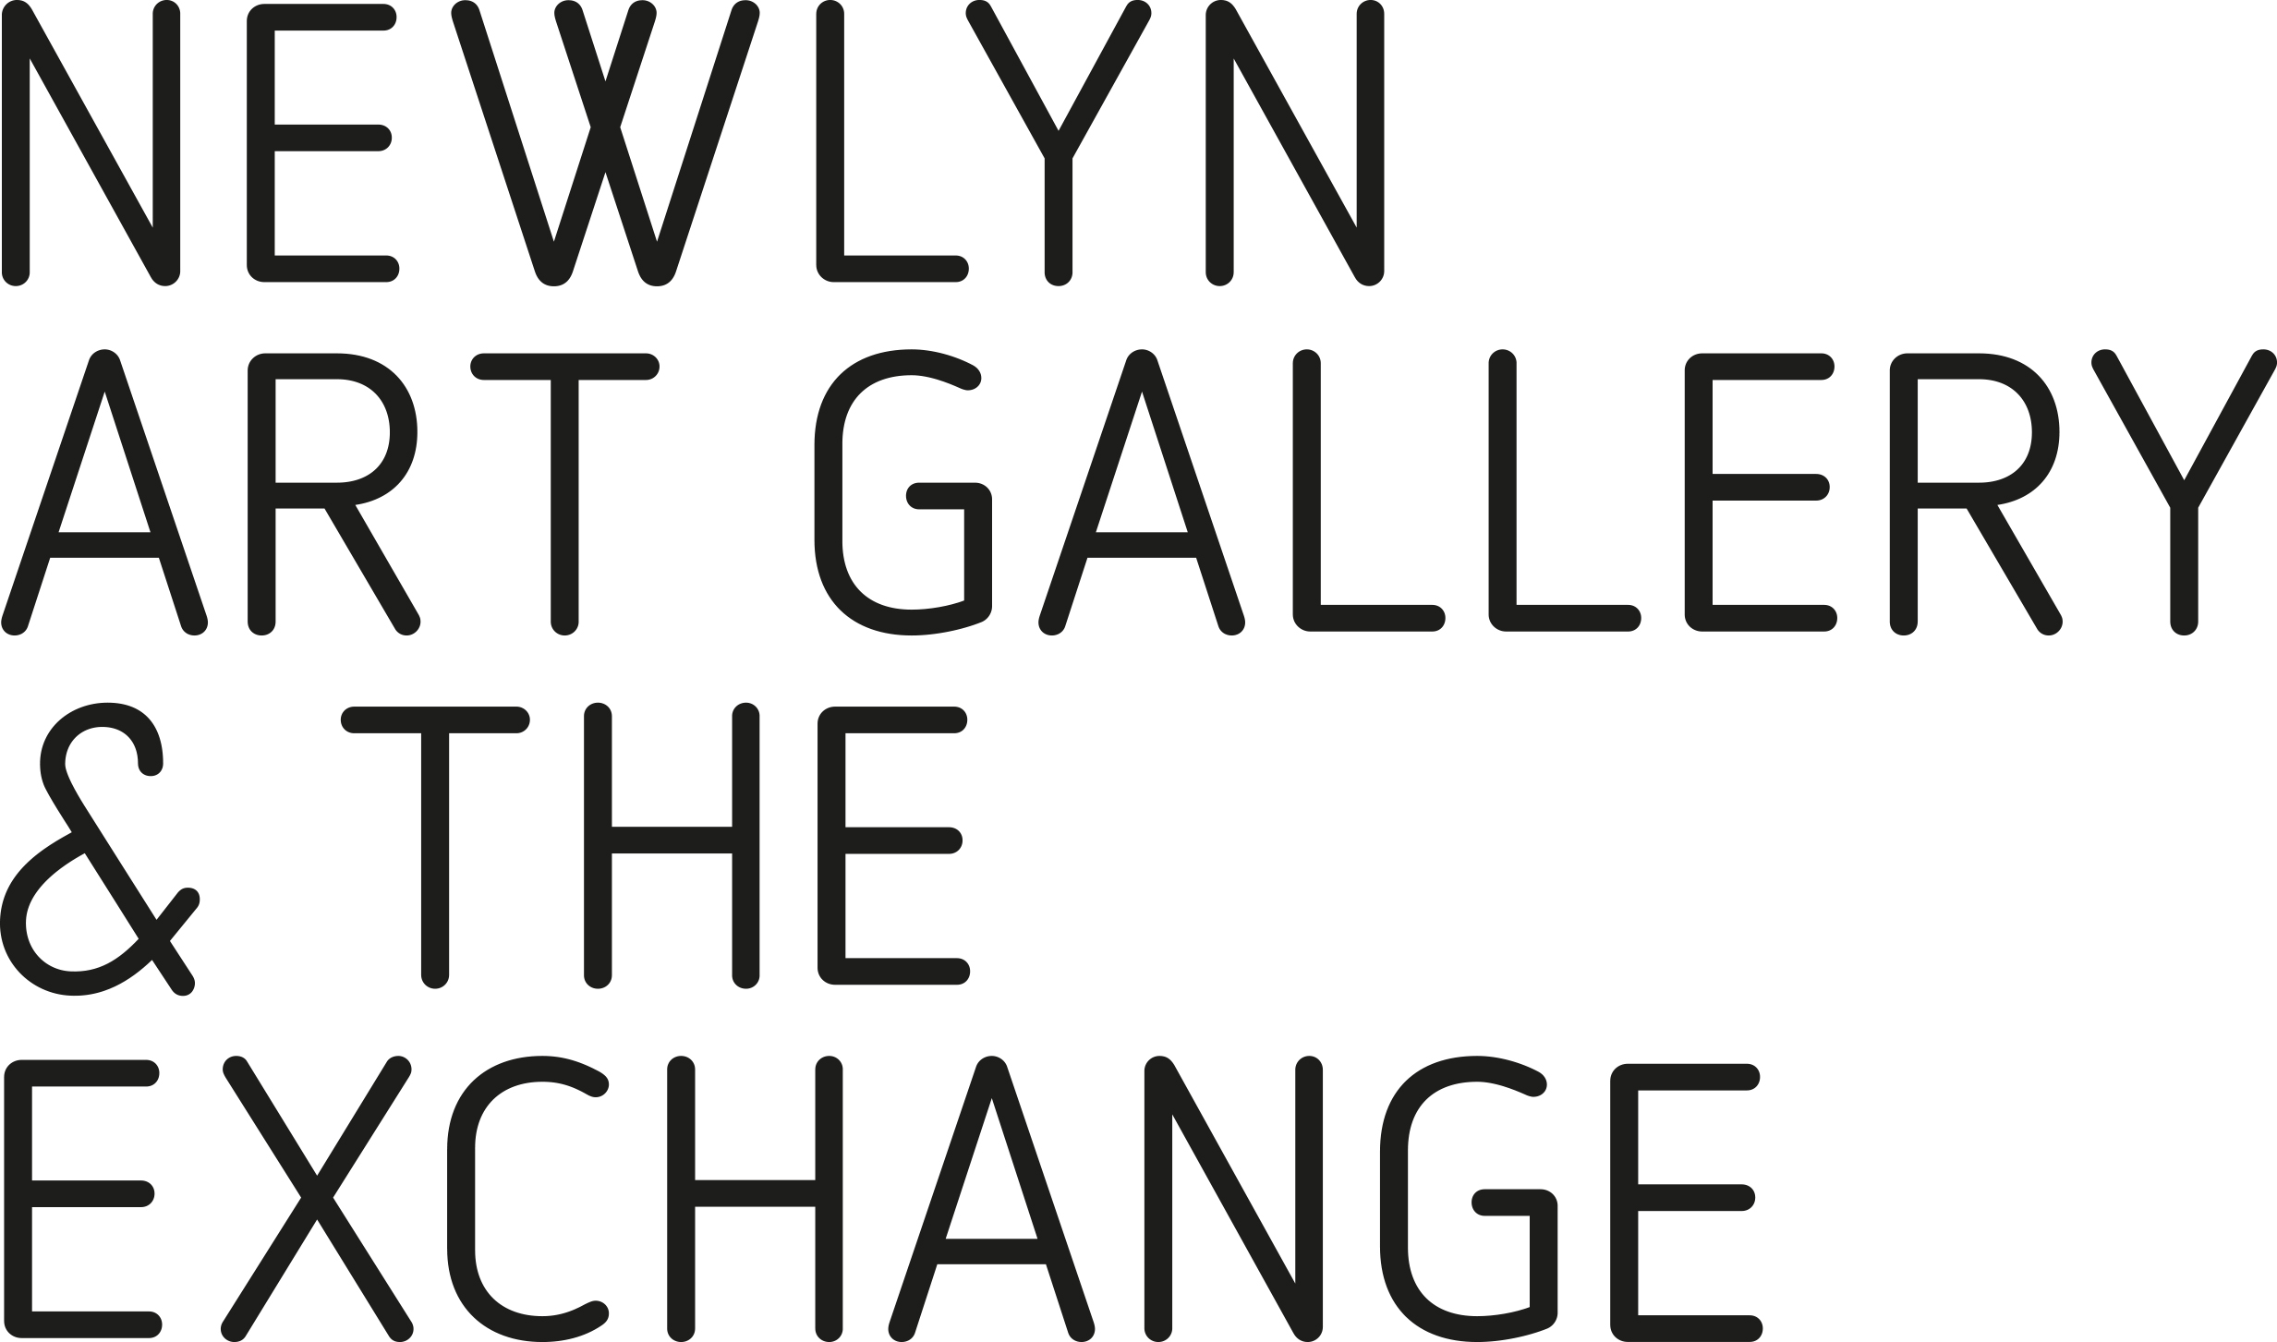
Robyn Denny

An Essay by Martin Holman

‘No painting should reveal all it has to say as a kind of instant impact,’ Robyn Denny told an interviewer in 1964. ‘Abstract painting,’ he went on, ‘that is painting which is not about subject-matter, if it is any good, should be as diverse and complex and strange and unaccountable, and unnameable as an experience, as any painting of consequence has been in the past.’

Throughout his 60-year career, Denny pursued that objective. Animating our encounter with the sensational red surface of Sweet O’Zeeta, 1985-86, is the small, irregularly-shaped area of white fading to pink in its midst. It could be three shapes, one placed upon another, advancing into our real space or importing an illusory light of its own. Or this inscrutable form is backing away, perhaps into a space we imagine lying beyond a fourth shape, the spectral haze that surrounds it.

These ambivalent events confront us at eye level so that colour fills our vision; it seems also to enclose us in its huge expanse and remind us of the painting’s tense, inescapable flatness. This patch of tainted whites, however, resonates with the gesture of its making: as we scrutinise its composition for a clue to meaning, we notice the white horizontal scored beneath. More complicated than a horizon, it sits sure as a clasp holding a mirage in place. It is as familiar in our memories as the drawn line on which we first learned to write, an early leap we took in our ability to communicate.

These sensations and speculations arise from the process of looking. For although Denny’s rigorously abstract paintings can appear at first sight to
be sparse but straightforward coloured forms arranged across a very large rectangular canvas, with time our engaged perceptions sense changes in
the relationships between those forms and colours, and between the painting and ourselves.

Indeed, the paintings invite us to navigate these shifting balances in our minds as if knowing that play heightens awareness of our surroundings. In this way, Denny erodes the separate spaces traditionally assigned to the viewer and to art, suggesting continuity between the ever-changing real world we occupy and the inner imaginary pictorial space that remains equivalent to, but distinct from, our own. The two never coincide.

Denny activates his audience into participants; engaged with the image, we deal with its possibilities. This proposition of sharing aesthetic experience was already well developed in the early 1960s. Framed on three sides by atmospheric blue and by systems of unbroken lines that our eyes instinctively travel, the central dark rectangle of Line-Up 2, 1962, rises from the bottom edge of the canvas and seems to echo our physical position in front of it. The vertical painting is as wide as our outstretched arms and, if we stand close, is just taller than our eyes can comfortably reach. That is, the scale, while big, feels human rather than overwhelming.

We encounter this impression again and again: in the clear, close-toned areas and boldly outlined central structure of By Day 4, 1967; multiplied in the asymmetrical outlined forms that collect in the upper region of Travelling, 1976-77, to push and reverse our perceptions of surface, depth and density; and in the luminescent Aday 2, 1968-73, which dispenses with linear edges altogether to stack multiple planes of colour into a towering central axis.

The imagined flow between real and illusory space is implied by analogy and not literal description. Indeed, we notice that the painting continues around to the sides, separating its surface from the wall to assert a discrete objectivity. Our attention, therefore, is concentrated on elements this perimeter contains. It is hard not to think of doors or arches giving notional access to our imaginations and through which one space gives onto another, in spite of the ambiguities perceived between them. Often working in series, Denny explored different perceptual formats that create a common ground with the spectator. In World-Wide I and II, both 1970, the interlocked horizontal strips of nuanced colour suggest steps into the bright ethereal space of the painting.

By the mid-1960s, Denny was established in the forefront of British contemporary painting, a position he maintained for at least the next decade
as his themes consistently evolved. His prominence was confirmed in 1966 when, with Anthony Caro, Bernard Cohen, Harold Cohen and Richard Smith,
he officially represented Britain at that year’s Venice Biennale, a selection
that reflected the international relevance that British non-figurative art had
by then achieved.

He had arrived at abstraction as an alternative to the figurative social realism and narrative-based neo-romanticism that had constituted the mainstream of British painting in the mid 1950s. He also resisted the allusion to landscape that pervaded the abstraction of painters like Terry Frost, Patrick Heron and Peter Lanyon in St Ives. By contrast, his vision was stimulated by the modernity of big city life where advertising slogans, traffic signs and succinct symbols directed the eye to wider horizons through the burgeoning mass media.

The centrifugal contrast of fractured diagonals and banded rectangles in Connections, 1964-65, in which the eye seeks out possible spaces, seems to evoke these congested urban environments in continual flux with pulsating music and hi-tech innovations. Interviewed in 1966, Denny remarked that ‘A painting is a kind of celebration. It says something about the complex nature of human experience which cannot be adequately expressed by simulating the proportions of the human figure with a two-dimensional diagrammatical analogy. And it impinges upon the perceptions of its audience at many levels and in many different ways.’

Denny’s choice of aloof, hard-edged and quasi-geometrical forms epitomises his mid-career journey, which this exhibition follows. It does not represent a quest for perfection or ordered expression, but the optimum format for the game-like relationship in which artist, his object and the viewer take on one another to complete the work. Although he drew on historical artistic influences like the sixteenth-century Venetian painter, Jacopo Tintoretto, to fuel the environmental definition of his ideas, from the late 1950s his cultural inspirations were primarily American. Denny was especially receptive to the spatial effects invoked in large-scale paintings by the abstract expressionists Mark Rothko and Barnett Newman.

Denny moderated the blast of more strident new American abstraction with his own accent of instinctual inclusivity, softer boundaries and muted, idiosyncratic tones. Colours, applied like uninflected membranes, seem autumnal, as shadowy as twilight or suffused with the hazy luminescence of light reflected on water that solicits spontaneous contact, as in Away, 1968-72. Titles, invariably ambiguous in significance, include intimations of time – of day, action or duration (as in Ago, Before, Growing, First Light) – and remind us
that this measurement is, with looking, integral to the disclosure promised by these paintings.

From 1981 Denny, who died in 2014 as critical interest in his work firmly revived, was based for five years in Los Angeles, the ultimate modern city. He responded to its complexity of spaces and intense climate by abandoning linear formality for gestural breadth in painting reminiscent of his first mature abstract work.

As before, however, physical scale is huge. But now colour fields of profound blue or lustrous red harbour the poetry of incidents that disturb the surface, such as the curtain of drips in Tuscany with Palm Trees, 1984-89. Retained, too, is the habitual elusiveness of meaning; the source of the unbalanced tricoloured nimbus in this painting remains unexplained. Is it a trick of the light or, perhaps, the happy coincidence of a recovered memory?

Text © Martin Holman and Newlyn Art Gallery & The Exchange 2017

www.newlynartgallery.co.uk

