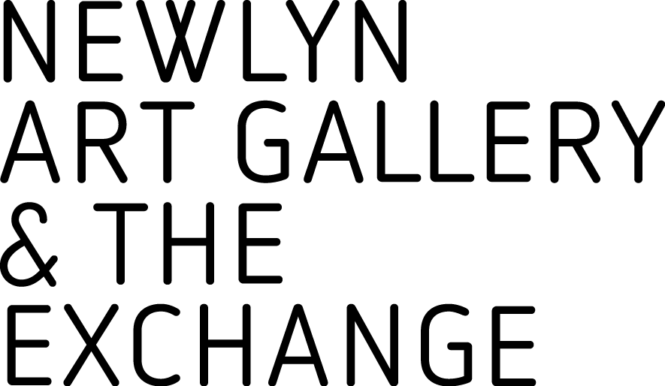
HIRE ENQUIRY FORM
NEWLYN ART GALLERY LTD

To get a quote/make a booking please complete this enquiry form and email it to Events Programmer Bettina Wenzel bettina.wenzel@newlynartgallery.co.uk or call the gallery on 01736 363715.
Please be advised that our exhibition programme runs across both venues. Please contact us for further information.

- Contact Name and Address

- Organisation/Company

- Contact Phone

- Contact Email

- Date(s) & Times required
This must include the time you need for setting up and tidying.

- Space(s) required

- Hire purpose/Type of event

- Number of people attending

- Will you charge admission for your event?

- Additional facilities required (ie: tables, chairs, catering etc.)

- Would you like us to provide a bar?

