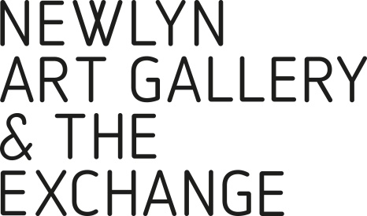JOB APPLICATION FORM

If you require this application form  
in any other format, please email   
[info@newlynartgallery.co.uk](mailto:info@newlynartgallery.co.uk) or call 01736 363715

|  |  |
| --- | --- |
| Position applied for: | CARETAKER / CLEANER AT NEWLYN ART GALLERY |

PERSONAL DETAILS:

|  |  |  |  |  |  |  |  |
| --- | --- | --- | --- | --- | --- | --- | --- |
| Title |  | Forename(s) |  | | Surname | |  |
| Address: |  | | | | | | |
| NI Number |  | | | | | | |
| Landline |  | | | Mobile Number | |  | |
| Email |  | | | | | | |

|  |  |
| --- | --- |
| Are there any restrictions on you taking up employment in the UK? | Y / N |
| If yes, please provide details below | |
|  | |

CRIMINAL RECORD:

|  |
| --- |
| Please note any criminal convictions except those 'spent' under the Rehabilitation of Offenders Act 1974. If none please state. In certain circumstances employment is dependent upon obtaining a satisfactory Disclosure & Barring Certificate from the Disclosure & Barring Service/Disclosure Scotland. |
|  |

REFERENCES (*please note here the names and contact details of two people we may contact for   
both character and work experience references*)

|  |  |
| --- | --- |
| Reference 1 Name and Contact Details | Reference 2 Name and Contact Details |
|  |  |
| Known in the capacity of: (i.e. Manager/Education) | Known in the capacity of: (i.e. Manager/Education) |
|  |  |
| May we contact them prior to interview? | May we contact them prior to interview? |
| Y/N | Y/N |

SUPPORTING STATEMENT

|  |
| --- |
| Please tell us why you are applying for this role and what makes you a good fit.  We’d like to hear about your skills, experience, and personal strengths, including any achievements you’re proud of.  You don’t need to have done this exact type of work before – if you have transferable experience from other jobs or areas of your life that show you’d be suitable for this role, we’d very much like to hear about that too. |
|  |

LEISURE:

|  |
| --- |
| Please note here your leisure interests, sports and hobbies, other pastimes etc. |
|  |

DISABILITY CONFIDENT EMPLOYER:

|  |  |  |  |
| --- | --- | --- | --- |
| As a Disability Confident employer, we will ensure that a fair and proportionate number of disabled applicants that meet the minimum criteria for this position will be offered an interview. Therefore, please indicate below whether you consider yourself to be disabled under the Equality Act 2010. Please mark ‘X’ in the appropriate box. | | | |
| Yes |  | No |  |
| Prefer not to say |  | Don’t know |  |

DECLARATION **(Please read this carefully before signing this application)**

1. I confirm that the above information is complete and correct and that any untrue or misleading information will give my employer the right to terminate any employment contract offered.
2. Should we require further information and wish to contact your doctor with a view to obtaining a medical report, the law requires us to inform you of our intention and obtain your permission prior to contacting your doctor. I agree that the organisation reserves the right to require me to undergo a medical examination. In addition, I agree that this information will be retained in my personnel file during employment and for up to six years thereafter and understand that information will be processed in accordance with the Data Protection Act.
3. I agree that should I be successful in this application, I will, if required, apply to the Disclosure & Barring Service/Disclosure Scotland for a Disclosure & Barring Certificate. I understand that should I fail to do so, or should the disclosure not be to the satisfaction of the company any offer of employment may be withdrawn or my employment terminated.

|  |  |
| --- | --- |
| Signed | Date |
|  |  |

Thank you for your application. Please send your completed form to [opportunities@newlynartgallery.co.uk](mailto:opportunities@newlynartgallery.co.uk)

