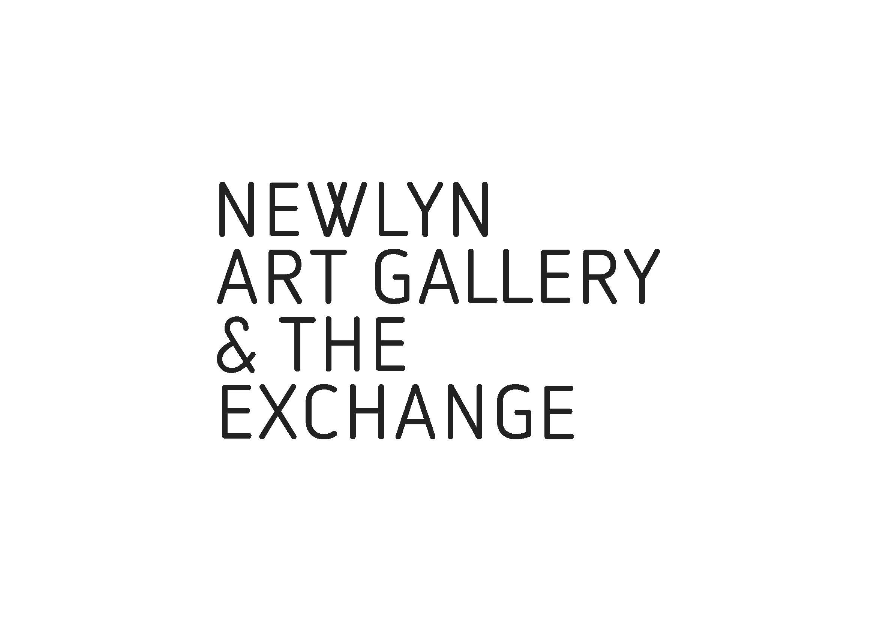BOTH OF OUR AWARD-WINNING  
VENUES SHOWCASE THE VERY BEST OF   
NATIONAL AND INTERNATIONAL CONTEMPORARY  
ART, INCLUDING THAT PRODUCED IN THE REGION.

**Each of the options below can be tailored to the specific learning objectives of your group.**

**Introduction to the Gallery & Exhibition KS1–5**

Groups are welcome to make self-directed visits, however it is essential that these are booked in advance. On booking, we will send you additional information on the current exhibitions. A brief introduction to the gallery and the exhibition by a member of the programme team is available on request.

**FREE – donations welcome.**

**Sketch Tours KS1-5**

A 90-minute artist led session. After a brief introduction to the exhibition, the group will be encouraged to explore the works and their themes further through a series of directed prompts.

Please bring own sketch book, all other materials provided.

**£350**

**Artist-led Activities KS 1–5**

This full or half-day artist led session directly informed by the current exhibition. It will begin with a tour and discussion, followed by a workshop responding to the artwork exhibited. The development of ideas and experimentation in methods and media is key to these sessions. Materials provided.

**£350 for ½ day, £475 for full day**

**PLEASE NOTE:**

The maximum number for group visits and workshops is 25.

If the class is larger, please split into two or more groups.

A deposit of 20% of the total cost will be required upon booking.

For self-led School and College visits, please download and complete [GROUP BOOKING FORM](https://newlynartgallery.co.uk/wp-content/uploads/2020/10/GROUP-BOOKING-FORM.docx) and return to [group.bookings@newlynartgallery.co.uk](mailto:group.bookings@newlynartgallery.co.uk)

For artist-led workshops please contact Cat Gibbard [cat.gibbard@newlynartgallery.co.uk](mailto:cat.gibbard@newlynartgallery.co.uk)