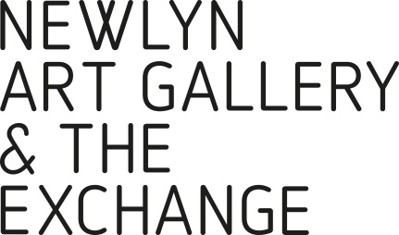
YOUNG PEOPLE’S ART PRIZE 2019

Submission Form
Deadline for entries is 17.00, Mon 18 Mar

Please attach a completed form for each piece of work

Name of School or College:

Address:

Contact name:

Contact telephone number:

Contact email address:

Name of student:

Age category of entrant please tick

11- 13

14 - 16

17 – 19

Title of work:

Process:

Work and this form (firmly attached) should be sent to:
Cat Gibbard, The Exchange, Princes Street, Penzance TR18 2NL

REGISTER YOUR REQUEST FOR WOMAN WITH A VAN COLLECTION BY MON 11 MAR

DEADLINE FOR ENTRIES IS 17.00, MON 18 MAR

