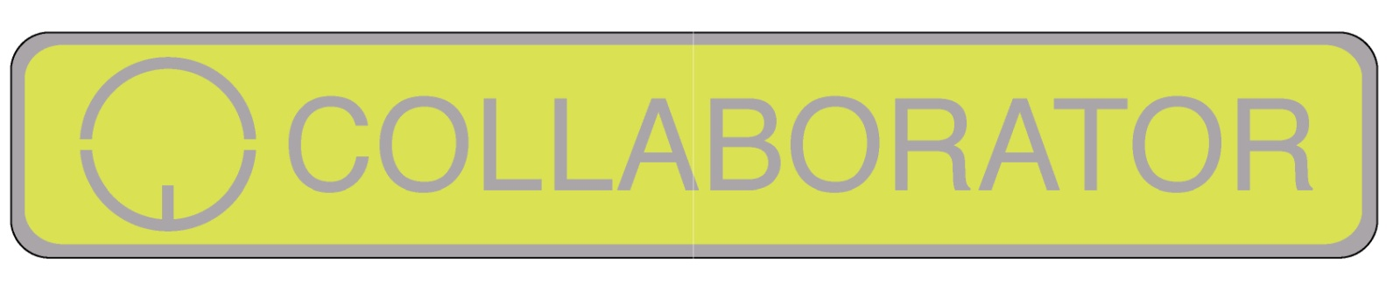
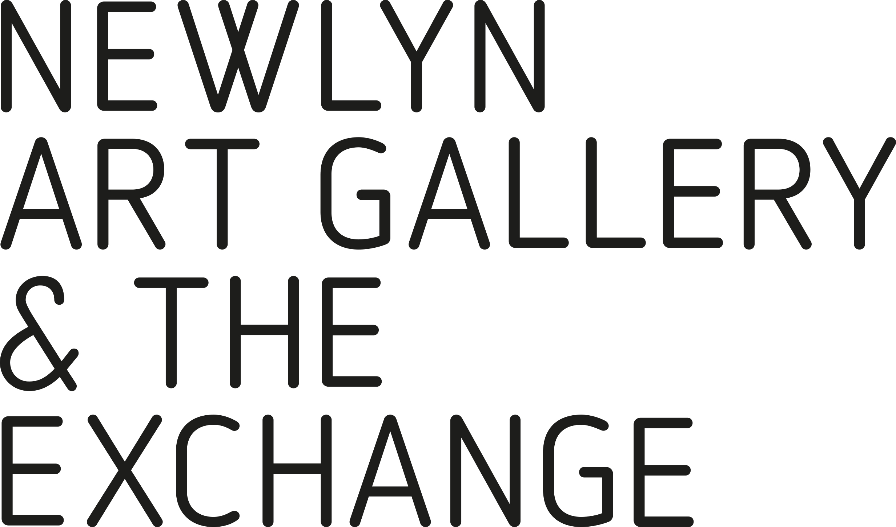

Aged under 30 with an interest in film, photography, illustration painting, printmaking…?
Why not join The Collaborators an informal, dynamic collective of art-based adventurers. Collaborators are sent regular emails detailing invitations and opportunities.

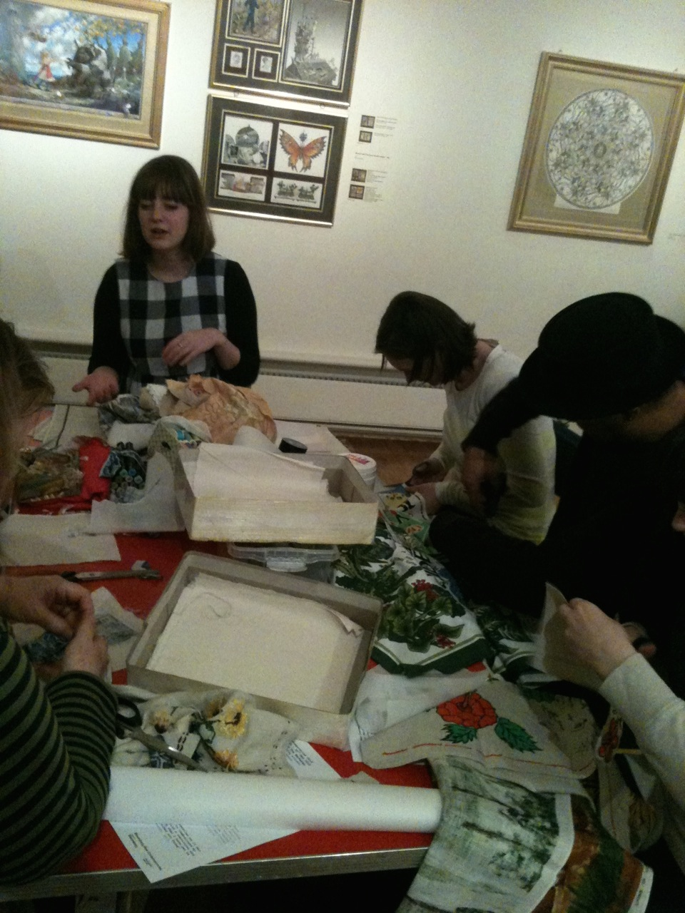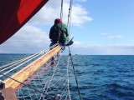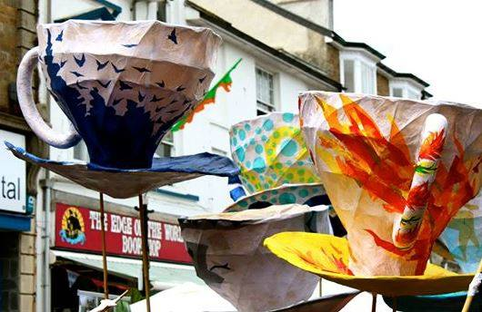
Interested in Collaborating? Complete the table below and return to thecollaborators@newlynartgallery.co.uk
Name
Date of Birth
Art Form
Email
Telephone
Postcode
How would you like to collaborate with us in the future?

See our Facebook Page: The Collaborators

